Experiment 7: Ballistic Pendulum

Ben Giftakis

TA: Ryan Preusse

PS181 Section 3

4/21/20

Data:

|  |  |  |  |  |  |  |  |  |  |  |
| --- | --- | --- | --- | --- | --- | --- | --- | --- | --- | --- |
| **M** | **m** | **N** | **hi** | **N** | **hf** | **N** | **y** | **N** | **x** | **N** |
| **(g)** | **(g)** | 5 | **(cm)** | 5 | **(cm)** | 10 | **(cm)** | 5 | **(cm)** | 10 |
| 274.2 | 69.81 | **`x** | 3.9 | **`x** | 13.82 | **`x** | 101.4 | **`x** | 302.2 | **`x** |
|  | 70.42 | **g** | 3.9 | **cm** | 13.95 | **cm** | 101.5 | **cm** | 302 | **cm** |
| **SM** | 69.79 | 70.026 | 3.9 | 3.898 | 13.82 | 13.873 | 101.2 | 101.34 | 303.8 | 304.55 |
| **(g)** | 70 | **Sx** | 3.9 | **Sx** | 13.9 | **Sx** | 101.3 | **Sx** | 308.9 | **Sx** |
| 0.1 | 70.11 | **g** | 3.89 | **cm** | 13.88 | **cm** | 101.3 | **cm** | 309.6 | **cm** |
|  |  | 0.257546 |  | 0.004472 | 13.8 | 0.045959 |  | 0.114018 | 307.1 | 4.630875 |
|  |  | **S`x** |  | **S`x** | 13.9 | **S`x** |  | **S`x** | 307.8 | **S`x** |
|  |  | **g** |  | **cm** | 13.88 | **cm** |  | **cm** | 309 | **cm** |
|  |  | 0.115178 |  | 0.002 | 13.89 | 0.014533 |  | 0.05099 | 298.3 | 1.464411 |
|  |  |  |  |  | 13.89 |  |  |  | 296.8 |  |

Table 1: Experimental Data with 1D Stats

|  |  |  |  |  |
| --- | --- | --- | --- | --- |
|  | momentum | error | PFE | velocity |
| initial | 46903.26246 | 239.5266 | 2.636692 | 669.7978 |
| final | 48139.95687 | 41.3273 |  | 139.8499 |
|  | g cm/s |  |  | cm/s |

Table 2: Calculated velocity, PFE, and momentum with error

Calculations:



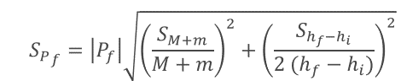

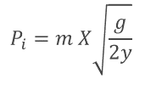

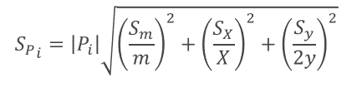

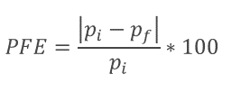

Results:

The initial momentum was calculated to be 46903.26246 +- 239.5265861 g cm/s. The final momentum calculated was 48139.95687+-41.3273 g cm/s. The initial and final velocities were calculated to be 669.7978 cm/s and 139.8499 cm/s respectively. The percent fractional error for the momentum was 2.64%.   
  
  
  
  
Discussion:

There were several sources for error to be introduced. Although there is no precision vs accuracy test that can be run on this, the data appears to be reasonable. While in theory the initial and final momentums should be the same there was a slight difference, but only 2.6% which isn’t too much for such an experiment, and falls within reason. I expect there to be random error introduced as in the video for the experiment, the pendulum was not perfectly motionless, not even close. It is quite likely that most of the error comes from this. If the experiment were to be run again, extra measures should be taken to ensure the pendulum is as still as possible.

Questions:  
1. (6 points) Calculate the kinetic energy of the system prior to collision.

Using this equation $=.5*70.026*{669.7978}^{2}=15,707,850.4292$ conversion from cm/s and g (divide by 10e7): 1.570785 J

2. (6 points) Calculate the kinetic energy of the system immediately after collision.

Using the previous equation $=.5*344.226*{139.8499}^{2}=3366185.11254$

Conversion from cm/s and g (divide by 10e7): 0.3366185 J

3. (6 points) Calculate the fractional energy loss:

Using this equation:

4. (6 points) Compute the ratio of the mass of the pendulum to the mass of the projectile pendulum system and compare with the fractional energy loss.

The two masses ratio: $\frac{70.026}{274.2+70.026}=0.203430305$ < FEL = 0.785700462

5. (6 points) Is there a violation of the law of conservation of energy in this inelastic collision (is there energy missing)? Explain.

There is a violation of the law of conservation of energy here. There was significant sources of energy loss are not accounted for. These could be due to error and imprecision in measuring the data, combined with energy transformation to other forms such as sound, heat, etc.